Bureau of Ocean Energy Management Environmental Studies Program

Technical Summary Specifications, Sample, and Template (2020)

Version: September 2021

Purpose
The Bureau of Ocean Energy Management (BOEM) Environmental Studies Program (ESP) requires a technical summary for every completed study. This document provides guidance on how to prepare the technical summary; it also includes a sample technical summary and a blank template.
Additional samples are available in ESPIS at https://marinecadastre.gov/espis/#/.

General Requirements
- Only one summary is needed for each study, even if more than one report is written for a study. More than one technical summary may be submitted as needed. A technical summary is also required if there is no final report for the study.
- To the extent possible, use plain language appropriate to a non-scientific audience.
- Use standard white pages (8.5 by 11 inches).
- The length may range from one and one-half to three single-spaced pages.
- All fields are required.
- Use the styles and formatting provided in the sample and template.
- Prepare and submit the technical summary using the Office 365 version (or earlier) version of Microsoft® Word.
- Any questions regarding the preparation of technical summaries should be addressed to the Contracting Officer’s Representative (COR) or Project Officer (PO).

Map of Study Area
The purpose of the map is to provide the reader with a quick reference of the location of the study. Include a map in the technical summary when the study footprint is not already depicted in the final report. If a map of the study footprint is already included in the final report, then including a map in the technical summary is optional. It is also recognized that a footprint map may not be appropriate for some technical summaries. For example, a technical summary prepared for a report based on a laboratory study with generic application of results to all OCS areas would not require a map. The COR or PO will determine if the vendor shall include a map.
Generally, the map shall be on a separate page from the text. Label major reference points on land (cities, state boundaries, etc.) and offshore features (canyons, banks, etc.). Provide latitude and longitude, map scale, and bathymetric contours at 200-m water depths and other meaningful isobaths.
For additional information, refer to the ESPIS Study Footprint Specifications on the ESP Data And Information Specifications webpage (https://www.boem.gov/esp-data-and-information-specifications).

Sample Technical Summary
Study Title | Characterizing and Quantifying Sea Lion and Seal Use of Offshore Manmade Structures Off California
Report Title | Characterizing and Quantifying California Sea Lion (Zalophus califorianus) Use of Offshore Oil and Gas Platforms in California
Report Number(s) (OCS Study) | BOEM 2016-009
Completion Date of Report | July 2016
Number of Pages | 36
Award Number(s) | M12PG00027
Sponsoring OCS Region or Office | Pacific
Applicable Planning Area(s) | Southern California
Fiscal Year(s) of Study Funding | FY 2012: $250,000
Costs by Fiscal Year | FY 2012: $0; FY 2013: $122,820.24; FY 2014: $42,608.02; FY 2015: $60,767.91; FY 2016: $19,538.77
Cumulative Project Cost | $245,734.94
Project Manager(s) | Robert L. DeLong and Anthony J. Orr
Affiliation of Project Manager(s) | Marine Mammal Laboratory, Alaska Fisheries Science Center, NOAA Fisheries, National Oceanic and Atmospheric Administration
Address of Project Manager(s) | 7600 Sand Point Way NE, Seattle, WA 98115
Principal Investigator(s) | Anthony J. Orr, Jeffrey D. Harris, Kari A. Hirschberger, Jeffrey L. Laake, Robert L. DeLong, and Gregory S. Sanders
Keywords | California sea lion, oil and gas platform, Pacific Outer Continental Shelf, pinniped, time-lapse camera system, Zalophus californianus

ABSTRACT: Oil and gas production platforms in federal waters offshore southern California provide haulout space near foraging areas for California sea lions (Zalophus californianus), a species protected under the Marine Mammal Protection Act. This study was conducted to quantify sea lion use of platforms and assess their age, sex, and seasonal-use patterns over a two-year period. A total of 464,174 photographs were obtained from all sampled platforms during this study. Although some human activities may be disruptive to resting pinnipeds, the presence of a structure on which they can rest in areas where they feed or forage is likely to be more beneficial than disruptive and to provide a net benefit.
BACKGROUND: There are 23 oil and gas production platforms in federal waters offshore southern California. These platforms provide haulout space near foraging areas for California sea lions (Zalophus californianus), a species protected under the Marine Mammal Protection Act. Information on abundance, age, sex, and seasonal-use patterns of California sea lions on oil and gas platforms is useful for the environmental review of ongoing activities and the eventual removal of platforms when oil and gas production ceases (i.e., decommissioning). Quantitative estimates of potential harassment, injury, or mortality for future activities may be derived from data collected during this study.
OBJECTIVES: Characterize California sea lion use of offshore oil and gas platforms in southern California. Quantify sea lion use of platforms and assess their age, sex, and seasonal-use patterns over a two-year period.
METHODS: Five of the 23 federal platforms offshore California were selected as focal study sites based on their geographical location and relative accessibility by sea lions. Time-lapse camera systems were deployed on these platforms from January 2013 to January 2015. Photos were taken every 30 minutes during day and night. A subsample of images was randomly selected from six-hour blocks of time throughout the day and during randomly selected days throughout each month. Individual sea lions were counted and identified to a particular age/sex class, when possible. Counts of animals by month and hour were conducted to examine intra-platform (temporal) and inter-platform (spatial) comparisons.
RESULTS: A total of 464,174 photographs were obtained from all sampled platforms during this study. A subsample of these photographs (ntotal = 12,489, Platform Elly = 1,981, Platform Gina = 1,960, Platform Habitat = 4,742, Platform Heritage = 2,551, Platform Harvest = 1,255) was used in data analyses. There were no consistent spatial trends (e.g., south to north) in numbers of sea lions using the platforms. Platform Habitat (central) had the highest counts of sea lions; whereas Platform Gina (south) had the lowest. There were no consistent seasonal trends in numbers across all platforms.
CONCLUSIONS: Offshore oil and gas platforms provide benefits to pinnipeds (especially California sea lions). Although some human activities may be disruptive to resting pinnipeds, the presence of a structure on which they can rest in areas where they feed or forage is likely to be more beneficial than disruptive and to provide a net benefit. The temporal and spatial variability in number of California sea lions using the platforms was pronounced for some platforms and minimal at others. Sea lions were observed on the platforms year-round and during all hours of the day. Most of the identified animals were juveniles. Proportionally relatively few of the animals were identified to a particular age/sex class in comparison to all counted individuals. Therefore, caution should be taken when using or interpreting findings.
STUDY PRODUCT(S):
- BOEM study report: Orr AJ, Harris JD, Hirschberger KA, Laake JL, DeLong RL, Sanders GS. 2016. Characterizing and quantifying California sea lion (Zalophus californianus) use of offshore oil and gas platforms in California. Camarillo (CA): US Department of the Interior, BOEM. 36 p. OCS Study BOEM 2016-009. Contract No.: M12PG00027.
- Complete photograph image library: (464,174 images) for future analyses. Copies of the digital libraries are archived in the BOEM Pacific Regional Office and NOAA’s Alaskan Fisheries Science Center.

MAP OF STUDY AREA: Figure 2 of report OCS Study BOEM 2016-009

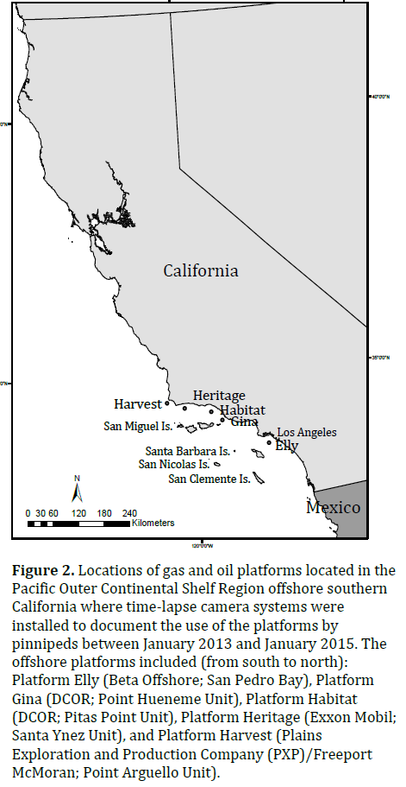

Technical Summary Template
Study Title
Report Title
Report Number(s) (OCS Study)
Completion Date of Report
Number of Pages
Award Number(s)
Sponsoring OCS Region or Office
Applicable Planning Area(s)
Fiscal Year(s) of Study Funding
Costs by Fiscal Year
Cumulative Project Cost
Project Manager(s)
Affiliation of Project Manager(s)
Address of Project Manager(s)
Principal Investigator(s)
Keywords
ABSTRACT: [Brief summary of study]
BACKGROUND: [Provide a brief context for the study. Note whether the study ties into, or builds off, other efforts.]
OBJECTIVES: [Clearly and succinctly state the overall purpose of the study. If there is more than one objective, use a list.]
METHODS: [Briefly describe the methods used.]
RESULTS: [Briefly explain the results. Where appropriate, tie the results to the objectives of the study.]
CONCLUSIONS: [Provide a concise conclusion for the study.]
STUDY PRODUCT(S): [List all study products (e.g., reports, publications, datasets, websites, educational resources).]
MAP OF STUDY AREA: [Insert map graphic and note figure and report number.]

