[Title]

[Insert cover graphic if available]

Version: September 2021
BEFORE YOU BEGIN,
PLEASE REVIEW THE ADDITIONAL INSTRUCTIONS
This document is provided as a template only. See instructions on how to prepare ESP studies reports and a sample study report provided on https://www.boem.gov/ESP-Data-and-Information-Specifications/.
This document includes notes and entry fields in brackets ([]). Delete this box, brackets, and notes when preparing your report.

[Title]

[Month Year]

Authors:
[Names]

Prepared under [Contract or Agreement and Number]
By
[Organization Name]
[Organization Address]

DISCLAIMER
[Select and fill out the appropriate disclaimer statement. Remove unused text, bracket marks, and highlighting.]
[Contracts] Study concept, oversight, and funding were provided by the U.S. Department of the Interior, Bureau of Ocean Energy Management (BOEM), Environmental Studies Program, Washington, DC, under Contract Number [INSERT NUMBER]. This report has been technically reviewed by BOEM, and it has been approved for publication. The views and conclusions contained in this document are those of the authors and should not be interpreted as representing the opinions or policies of BOEM, nor does mention of trade names or commercial products constitute endorsement or recommendation for use.
[Interagency and Intra-Agency Agreements (select “Interagency” for agreements with Agencies outside of the U.S. Department of the Interior (DOI) or “Intra-Agency” for Agencies within DOI)] This study was funded, in part, by the U.S. Department of the Interior, Bureau of Ocean Energy Management (BOEM), Environmental Studies Program, Washington, DC, through [Interagency or Intra-Agency] Agreement Number [INSERT NUMBER] with the [INSERT ORGANIZATION]. This report has been technically reviewed by BOEM, and it has been approved for publication. The views and conclusions contained in this document are those of the authors and should not be interpreted as representing the opinions or policies of BOEM, nor does mention of trade names or commercial products constitute endorsement or recommendation for use.
[Cooperative Agreements] Study collaboration and funding were provided by the U.S. Department of the Interior, Bureau of Ocean Energy Management (BOEM), Environmental Studies Program, Washington, DC, under Agreement Number [INSERT NUMBER]. This report has been technically reviewed by BOEM, and it has been approved for publication. The views and conclusions contained in this document are those of the authors and should not be interpreted as representing the opinions or policies of BOEM, nor does mention of trade names or commercial products constitute endorsement or recommendation for use.
REPORT AVAILABILITY
To download a PDF file of this report, go to the U.S. Department of the Interior, Bureau of Ocean Energy Management Data and Information Systems webpage (http://www.boem.gov/Environmental-Studies-EnvData/), click on the link for the Environmental Studies Program Information System (ESPIS), and search on 20xx-xxx. The report is also available at the National Technical Reports Library at https://ntrl.ntis.gov/NTRL/.
CITATION
Lastname FM, Lastname FM, Lastname FM (Contractor name, City, ST). Year. Report title in sentence caps. City (ST): U.S. Department of the Interior, Bureau of Ocean Energy Management. xx p. Report No.: OCS Study BOEM 20xx-xxx. Contract No.: xxxxx.
ABOUT THE COVER
[Optional, for cover graphic/photo credit]
ACKNOWLEDGMENTS
[Optional. Use separate page, if necessary, for additional space.]
Contents
List of Figures iv
List of Tables iv
List of Abbreviations and Acronyms v
1 Heading 1 1
1.1 Heading 2 1
1.1.1 Heading 3 1
2 References [or Works Cited] 3
Appendix A: Heading 7 Style 4
Appendix B: Sample Page in Landscape Orientation 5

List of Figures
Figure 1. Figure caption in sentence capitalization 2

List of Tables
Table 1. Sample table using preset styles 1
Table B-1. Sample table in landscape orientation 5

List of Abbreviations and Acronyms
[short form] | [long form, add more rows to this table to add lines]
BOEM | Bureau of Ocean Energy Management

Heading 1
Do not modify the style definitions in this template. Add a new style only if necessary.

Heading 2
This is the Normal style. Heading styles in this template are all followed by the Normal style in the next paragraph. Spacing between headings and paragraphs is already set. Heading styles are kept together with the following paragraphs to prevent awkward page breaks.

Heading 3
See a sample table in Table 1. Use the Table Title style to automatically include the table title in the List of Tables. Styles are provided for column headers, row headers, and table cells (text, number left aligned, and number right aligned).
To align the numbers in a column on the decimal as shown in the fourth column of Table 1.
- Use the “Table Cell (left)” style
- Select the cells you want to align
- Double click on the lower part of the ruler around the place you want to put the decimal (or go to Paragraph > Tabs and enter an amount for the distance of the decimal from the left cell margin)
- Select “Decimal,” “Set,” and “OK.”
Table 1. Sample table using preset styles
Table Header (center) | Table Header (center) | Table Header (center) | Table Header (center)
Table Header (left) | Table Cell (left) | Table Cell (left) | 4.231
Table Header (left) | Table Cell (left) | Table Cell (left) | 888.56
Table Header (left) | Table Cell (left) | Table Cell (left) | 0.38
Note: Use the Table Notes style for sources or additional info.

Heading 4
Use Headings 1–6 for the main body of the report. Headings 1–3 are listed in the Contents.
Use Headings 7–9 for the appendix or appendices. Heading 7 is listed in the Contents. Headings 8 and 9 may be used if needed.

Heading 5
- List Paragraph style is default for bulleted lists.
- List Paragraph style is default for bulleted lists.
- List Paragraph style is default for bulleted lists.
- Use the Numbered List style for numbered lists.
  - Use the Numbered List style for numbered lists.
    - Use the Numbered List style for numbered lists.

Heading 6
Figure 1 included below. Figure Caption style is automatically included in the List of Figures. Figure Notes style is provided for additional information.
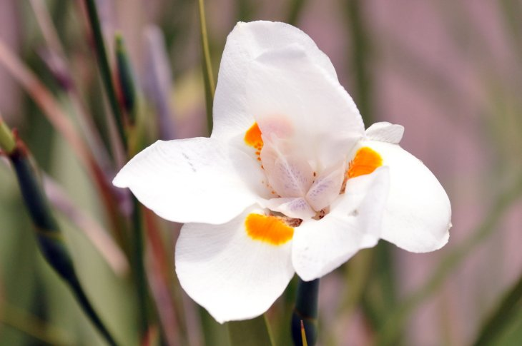
Figure 1. Figure caption in sentence capitalization
Use the Figure Notes style for giving the source or additional info about the figure.

References [or Works Cited]
[CSE] Council of Science Editors. 2014. Scientific style and format: the CSE manual for authors, editors, and publishers. 8th ed. Chicago (IL): University of Chicago Press. 722 p.

Appendix A: Heading 7 Style

Heading 8 Style
Normal style

Heading 9 Style
Normal style

Appendix B: Sample Page in Landscape Orientation
Table B-1. Sample table in landscape orientation
Table Header (center) | Table Header (center) | Table Header (center) | Table Header (center) | Table Header (center)
Table Header (left) | Table Cell (left) | Table Cell (left) | Table Cell (center) | Table Cell (right)
Table Header (left) | Table Cell (left) | Table Cell (left) | Table Cell (center) | Table Cell (right)
Notes: [Insert notes]
.
U.S. Department of the Interior (DOI)
DOI protects and manages the Nation's natural resources and cultural heritage; provides scientific and other information about those resources; and honors the Nation’s trust responsibilities or special commitments to American Indians, Alaska Natives, and affiliated island communities.
Bureau of Ocean Energy Management (BOEM)
BOEM’s mission is to manage development of U.S. Outer Continental Shelf energy and mineral resources in an environmentally and economically responsible way.
BOEM Environmental Studies Program
The mission of the Environmental Studies Program is to provide the information needed to predict, assess, and manage impacts from offshore energy and marine mineral exploration, development, and production activities on human, marine, and coastal environments. The proposal, selection, research, review, collaboration, production, and dissemination of each of BOEM’s Environmental Studies follows the DOI Code of Scientific and Scholarly Conduct, in support of a culture of scientific and professional integrity, as set out in the DOI Departmental Manual (305 DM 3).

